In the event that you have some issues or concerns regarding your child’s schooling we would ask that follow the process below.
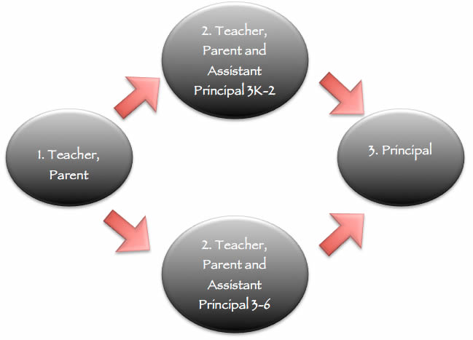
- Email the class teacher to make an appointment, stating what it is you would like to talk about and cc the relevant assistant principal.
- If you are not happy with the outcome of the meeting with the teacher, notify the teacher and email the relevant assistant principal to request a meeting
- A three way meeting with be scheduled with the Teacher and appropriate Assistant Principal for your child’s year level.
- If a resolution is not found during this three way meeting, an interview with the Principal may be scheduled.

If you require further information about this policy, please see your child’s class teacher or a member of the school administration.
When dealing with an issue or concern regarding your child’s schooling it is important to note:
- That it is important to remain calm and objective.
- Determine whether this adverse situation can be a learning experience for your child. Can they work this problem out for themselves?

- Talking to other parents about your concerns can create confusion and uncertainty and be detrimental to the community; Please keep issues confidential.
- Make an appointment through the correct channels.
- Avoid approaching the teacher first thing in the morning and expecting an appointment on the spot.
- We are here to help so try to stay calm and avoid approaching the teacher on the defensive.
- Be prepared to listen to the teacher and be open to discuss the issue.
- If you are not satisfied with the outcome of the meeting with the teacher, let the teacher know that you are taking the matter to the Assistant Principal.
- Always respect the dignity of all parties involved.
- All matters concerning all individuals are of a confidential nature and should remain so under all circumstances.
- Teacher Assistants are not at liberty to discuss school matters with parents. Please do not approach them for information.
- Anonymous letters, petitions, letters signed by groups of parents, group meeting requests and the like are not in line with how we as a Catholic Community deal with issues and concerns. These methods to resolve issues are considered intimidating and will not be acknowledged.
- We believe that we are a great school. From time to time issues will occur, we need you to work calmly and rationally with us to come to a resolution together.
- There will be times when staff make mistakes too, we are human.
- When you accept the offer to enrol your child at St Maria Goretti’s you agree to support and trust the staff who are employed by the school and the policies that exist within it.
- At all times remember that you are in partnership with the school and decisions are made with the best intentions and interest of all children.
“Celebrate what is right with the world do not Wallow in what is wrong with it!”

